Order Of Service

Singing: Psalm 119a—CW page 109

Reading: Psalm 67

Opening Hymn: TLH 23

Reading: Ephesians 6:1-9

Request Hymn: CW Supplement 702

Reading: Mark 12:28-34

Sermon Hymn: TLH 658

Sermon Text: Luke 22:35-38

Two Swords

Prayer

The Apostles’ Creed, TLH page 12

Holy Communion

The Lord's Prayer

The Blessing

Closing Hymn: TLH 46

************

Bible Study: Lambs: TBA
Sheep: Deuteronomy 4:41-49
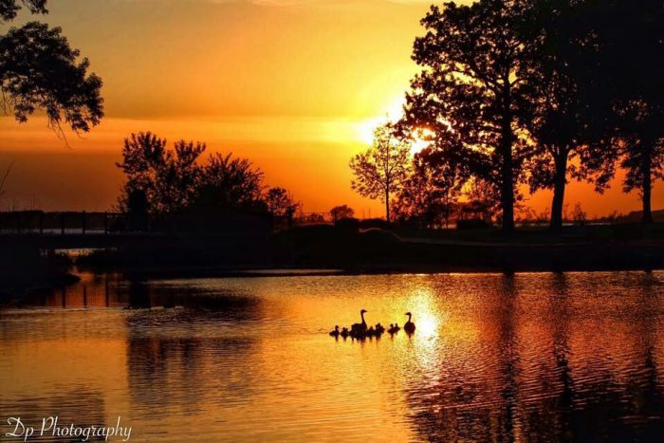

Summer In Minnesota

Water
Of
Life

9 July 2023

W A T E R O F L I F E

Independent Christian Church—Conservative Lutheran Doctrine

Worship Service: 9:30 a.m.

Larry Cooper, Pastor E-Mail address:
lcooper@wateroflife.cc
Web Site:
www.wateroflife.cc

* * * * * * * * * * * * * * * * * * * * * * * * * * *

Sermon Text: Luke 22:35-38

Two Swords

* * * * * * * * * * * * * * * * * * * * * * * * * * *

35 And he said unto them, When I sent you without purse, and scrip, and shoes, lacked ye any thing? And they said, Nothing.
36 Then said he unto them, But now, he that hath a purse, lethim take it, and likewise his scrip: and he that hath no sword, let him sell his garment, and buy one.
37 For I say unto you, that this that is written must yet be accomplished in me, And he was reckoned among the transgressors: for the things concerning me have an end.
38 And they said, Lord, behold, here are two swords. And he said unto them, It is enough.



